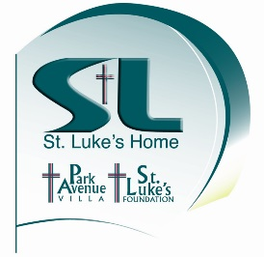

St. Luke’s Home Foundation • (701) 456-8265
242 10th St. W
Dickinson, ND 58601

Yes! I / we want to support St. Luke’s Home Foundation with a gift / pledge of $ ___________.
Name (as you wish to be recognized*)___________________________________________________________
Contact person / title if business / organization gift ___________________________________________
Spouse / partner, if applicable ___________________________________________________________
Address _____________________________________________________________________________
City ________________________ State _____ Zip _____________ E-mail______________________
Telephone: Daytime _________________ Evening _________________ Fax ____________________

* Donors will be recognized in various St. Luke’s Home Foundation publications. Please indicate above exactly how you prefer to be recognized. If you prefer to remain anonymous, check this box. 
Please check, as appropriate:  Current donor  New donor
 Address change  Name change
 Add me to St. Luke’s newsletter list  Send volunteer information
 I / we have included XYZ in our will

My gift is:  In honor of  In memory of _____________________________________________________ Please acknowledge to: Name____________________________________________________________________________________
Address ___________________________________________________________________________________ City ______________________ State ___ Zip __________ E-mail ___________________________________

 Enclosed is my check of $___________ made payable to St. Luke’s Home Foundation. (If this is a partial payment, please pay the balance no later than December 31, the end of St. Luke’s Home Foundation’s fiscal year. St. Luke’s Home Foundation will send you reminder notices quarterly. Thank you.)

 Please charge my VISA or Master Card (Please circle which one. For gifts of $250 or more please.)
Account # _________________________________________ Expiration date __________________________
Authorizing signature_______________________________________________________________________

Thank you!
St. Luke’s Home Foundation is tax-exempt under section 501(c)3 of the Internal Revenue Code. All contributions are tax-deductible to the full extent allowed by law.

